PROJECT REPORT ON

Implementing crm for result Tracking of A candidate with internal marks

Introduction:

The project aim is to provide real-time knowledge for all the students who have basic knowledge of Salesforce and Looking for a real-time project. This project will also help those professionals who are in crosstechnology and want to switch to Salesforce. With the help of this project they will gain knowledge and can include it into their resume as well.

Creating a developer org in salesforce.

1. Go to developers.salesforce.com/Signup
2. Click on sign up.
3. On the sign-up form, enter the following details:
   1. First name & Last name:Vadde Ram mohan
   2. Email:[rm77319@gmail.com](mailto:rm77319@gmail.com)
   3. Role: Admin
   4. Company: sree vidyanikethan degree college
   5. County: India
   6. Postal Code: 517102
   7. Username: [rm77319@gmail.com](mailto:ram77319@gmail.com)

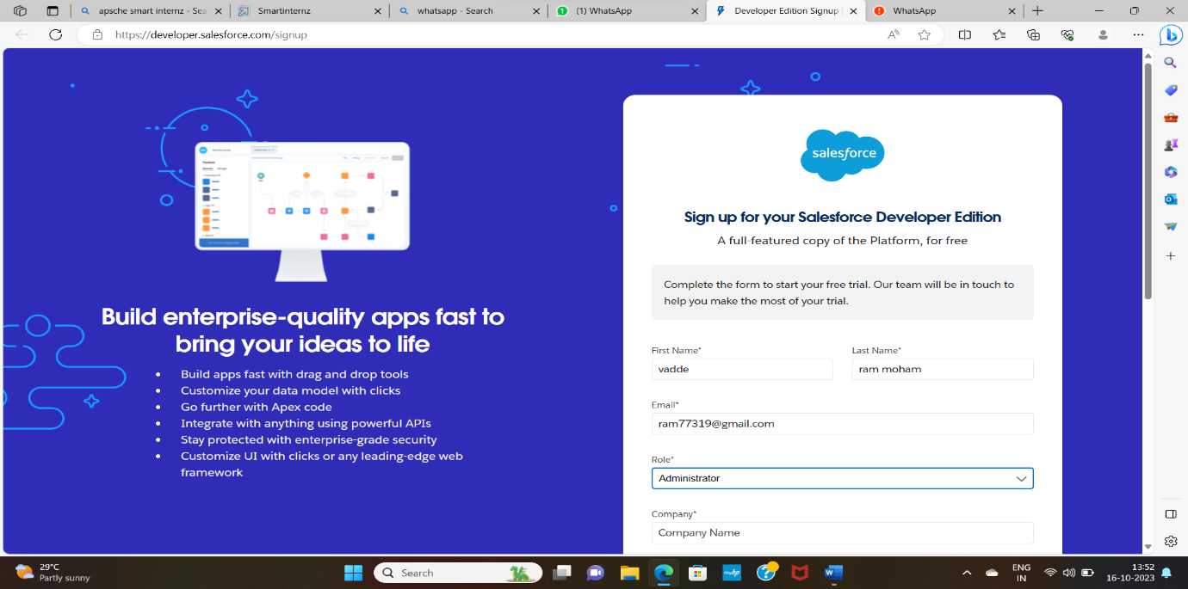

Account Activation

Go to the inbox of the email that you used while signing up. Click on the verify account to activate your account.

The email may take 5-10mins, as

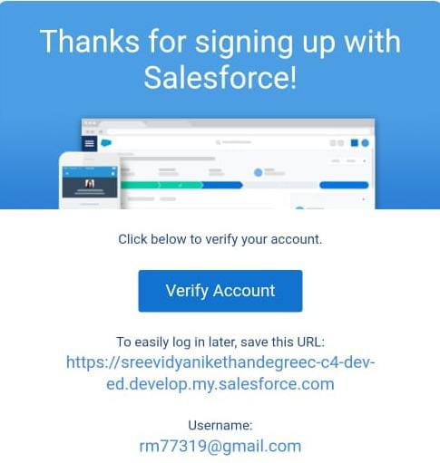

Login To Your Salesforce Account

1. Go to salesforce.com and click on login.
2. Enter the username and password that you just created.

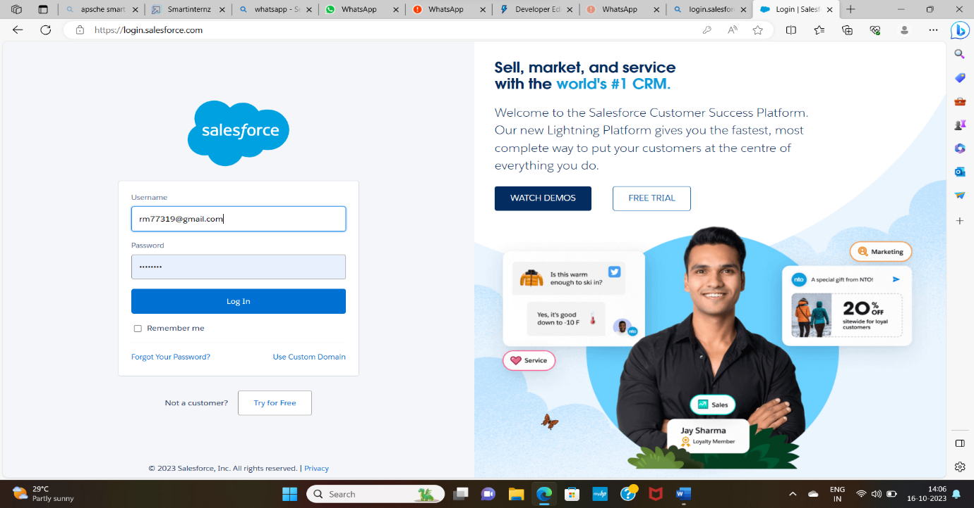

3.After login this is the home page which you will see.

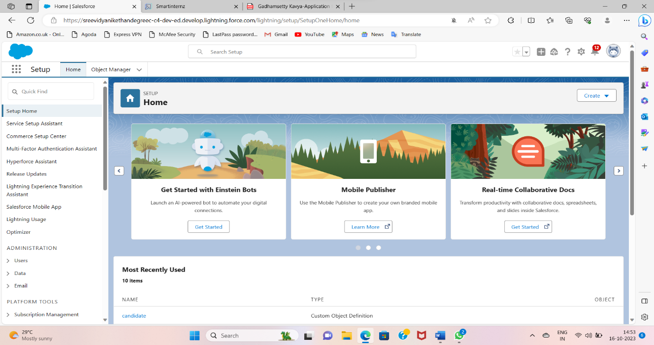

**Object**

Salesforce objects are database tables that permit you to store data that is specific to an organization.Salesforce objects are of two types:

1. Standard Objects: Standard objects are the kind of objects that are provided by salesforce.com such as users, contracts, reports, dashboards, etc.

2. Custom Objects: Custom objects are those objects that are created by users. They supply information that is unique and essential to their organization. They are the heart ofany application and provide a structure for sharing data.

### Creation Of Semester Object For Candidate Internal Result Card

1. Click on the gear icon and then select Setup.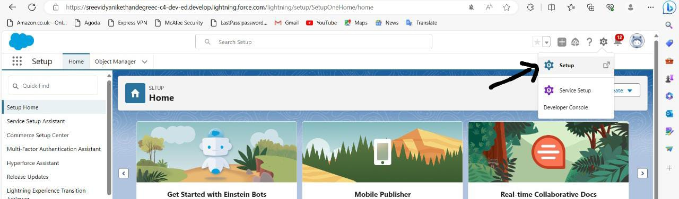

2. Click on the object manager tab just beside the home tab.

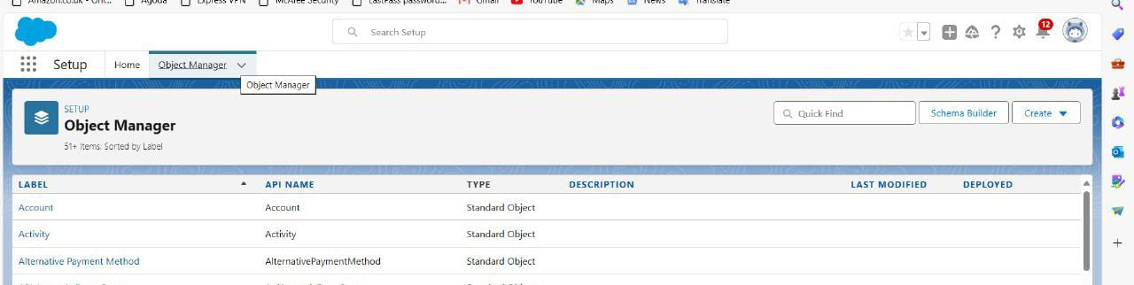

1. After the above steps, have a look on the extreme right you will find a Create Dropdown click on that and select Custom Object.

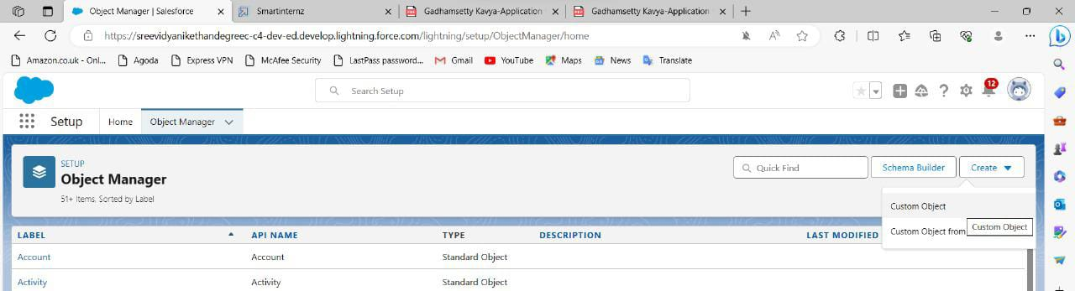

4. On the Custom Object Definition page, create the object as follows:

5. Label: Semester

6. Plural Label: Semesters

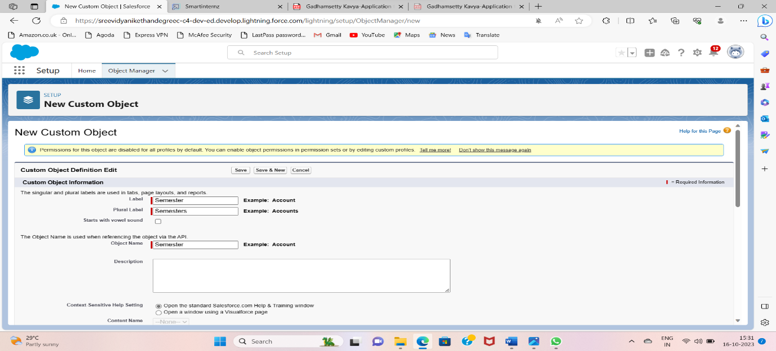

7. Record Name: Semester Name

8. Check the Allow Reports

9. Check the Allow Search

10.Click Save.

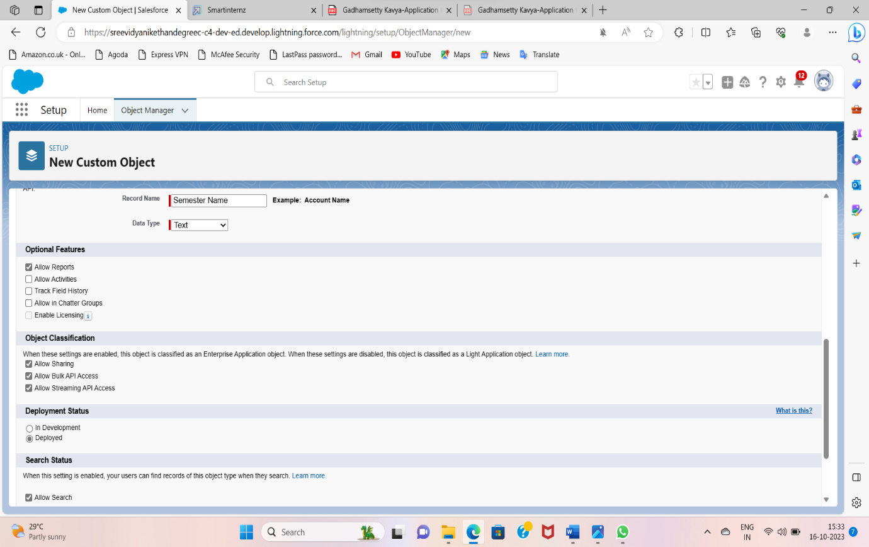

### Creation Of Semester Tab For Candidate Internal Result Card

1. Enter tabs in quick find and select tabs

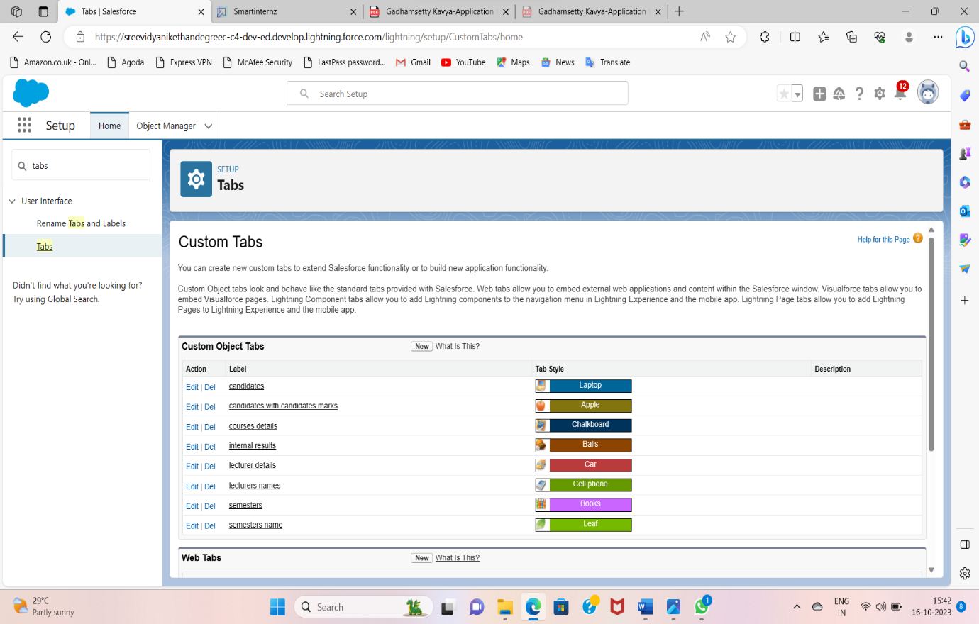

2. Under Custom Object Tabs, click New.

3. For Object, select Semester.

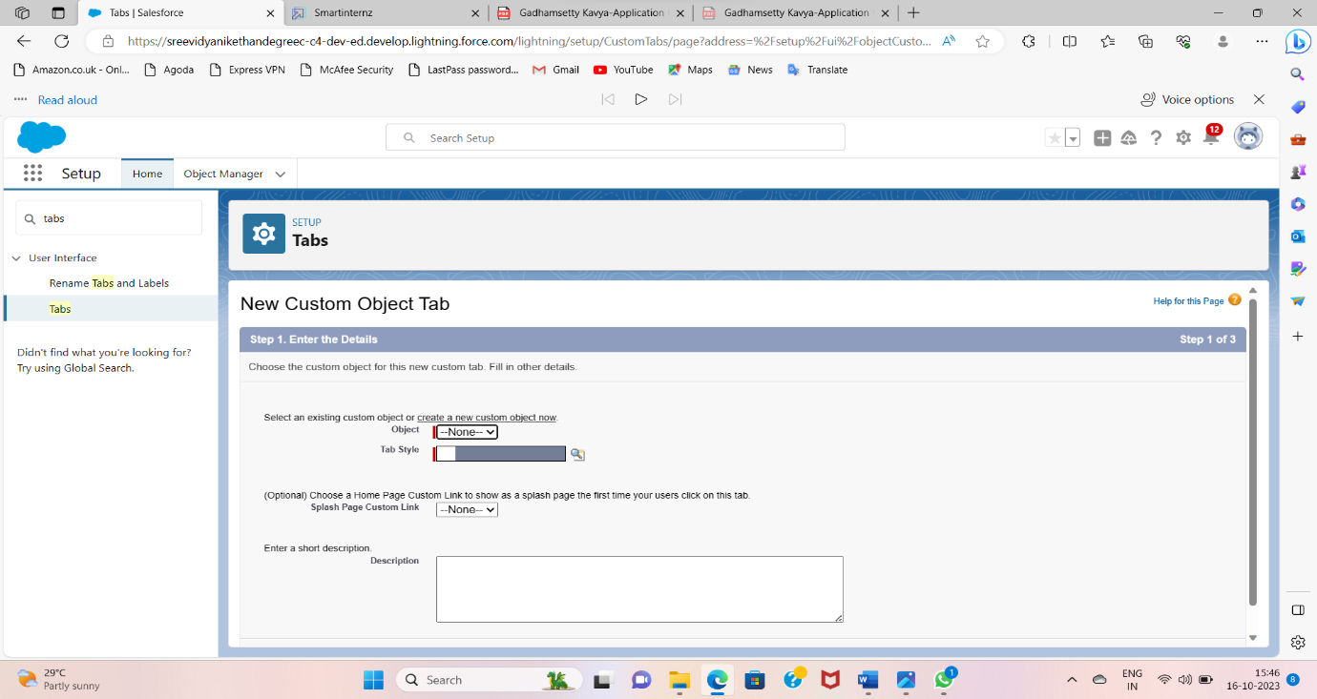

4. For Tab Style, select any icon.

5. Leave all defaults as is. Click Next, Next, and Save

6. In the same way create Tabs for all Custom Objects -Candidate, Course Details, Lecturer Details, Internal results.

### Create The Candidate Internal Result Card App

1. From Setup, enter App Manager in the Quick Find and select App Manager.

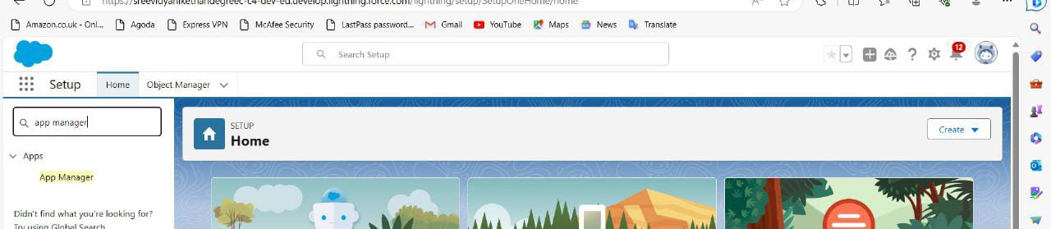

2. Click New Lightning App.

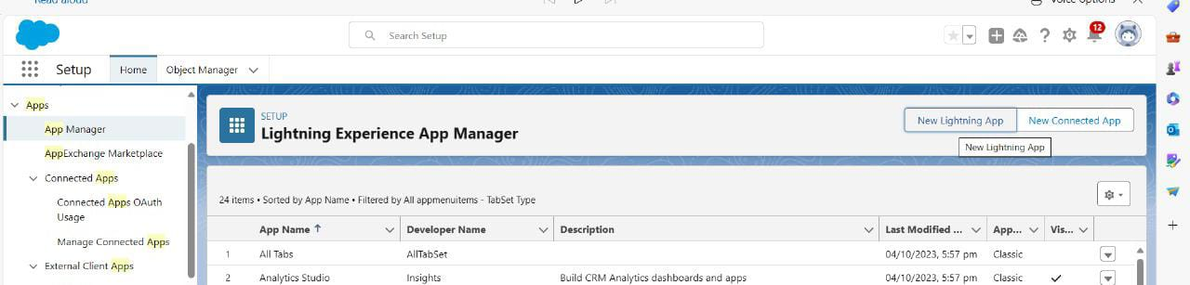

3. Enter **Candidate Internal Result Card** as the App Name, then click next

4. Under App Options, leave the default selections and click next.

5. Under Utility Items, leave as is and click Next.

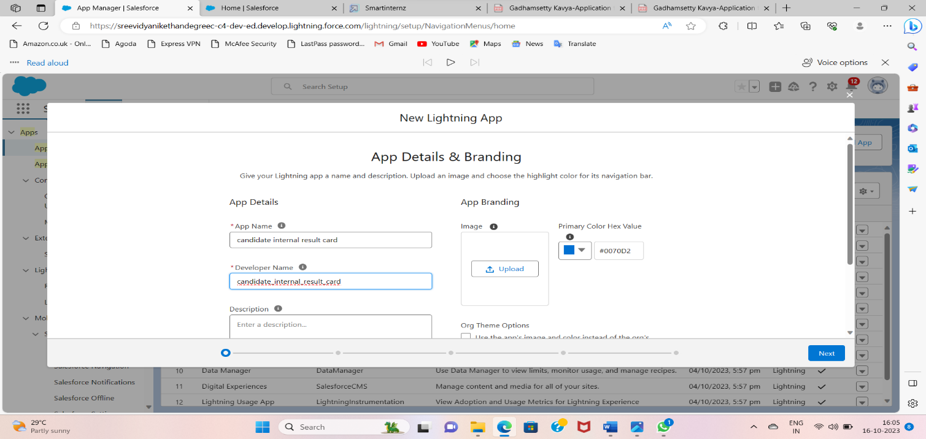

6. From Available Items, select **Semester**, **Candidate**, **Course Details**, **Lecturer Details**, **Internalresults**, **Reports**, and **Dashboards** and move them to Selected Items.

7. Click Next.

From Available Profiles, select System Administrator and move it to Selected Profiles. Click Save & Finish

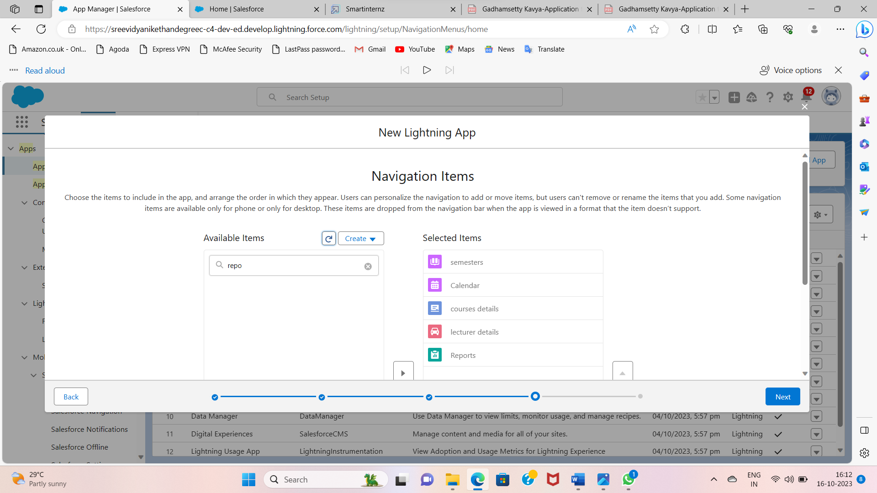

### Creation Of Text Field On "Lecturer Details" & Look Up Field For The “Candidate” Object

1.Click the gear icon and select Setup. This launches Setup in a new tab.

2. Click the Object Manager tab next to Home.

3. Select Lecturer Details

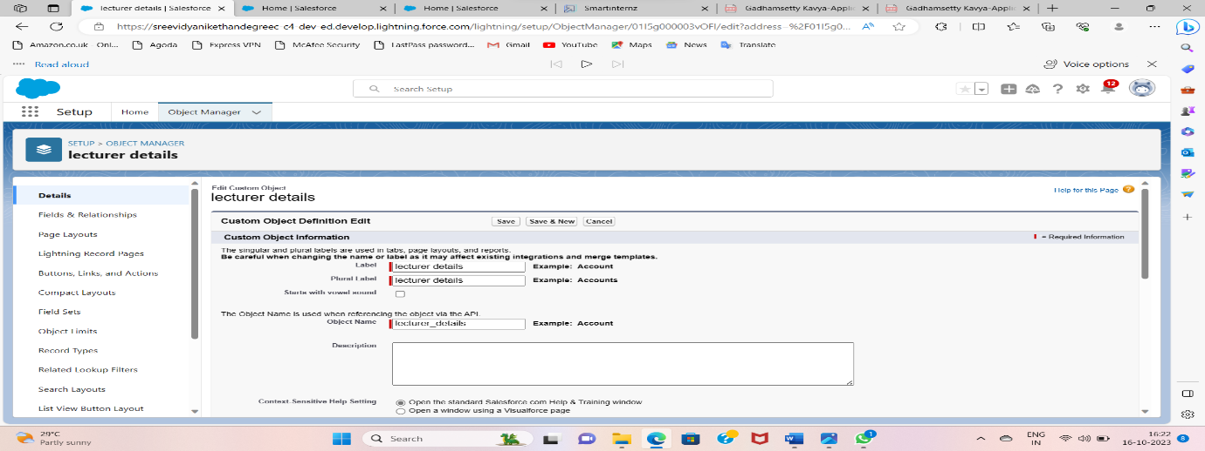

4. Select Fields & Relationships from the left navigation

5. Click New

6. Select the Text as the Data Type, click next.

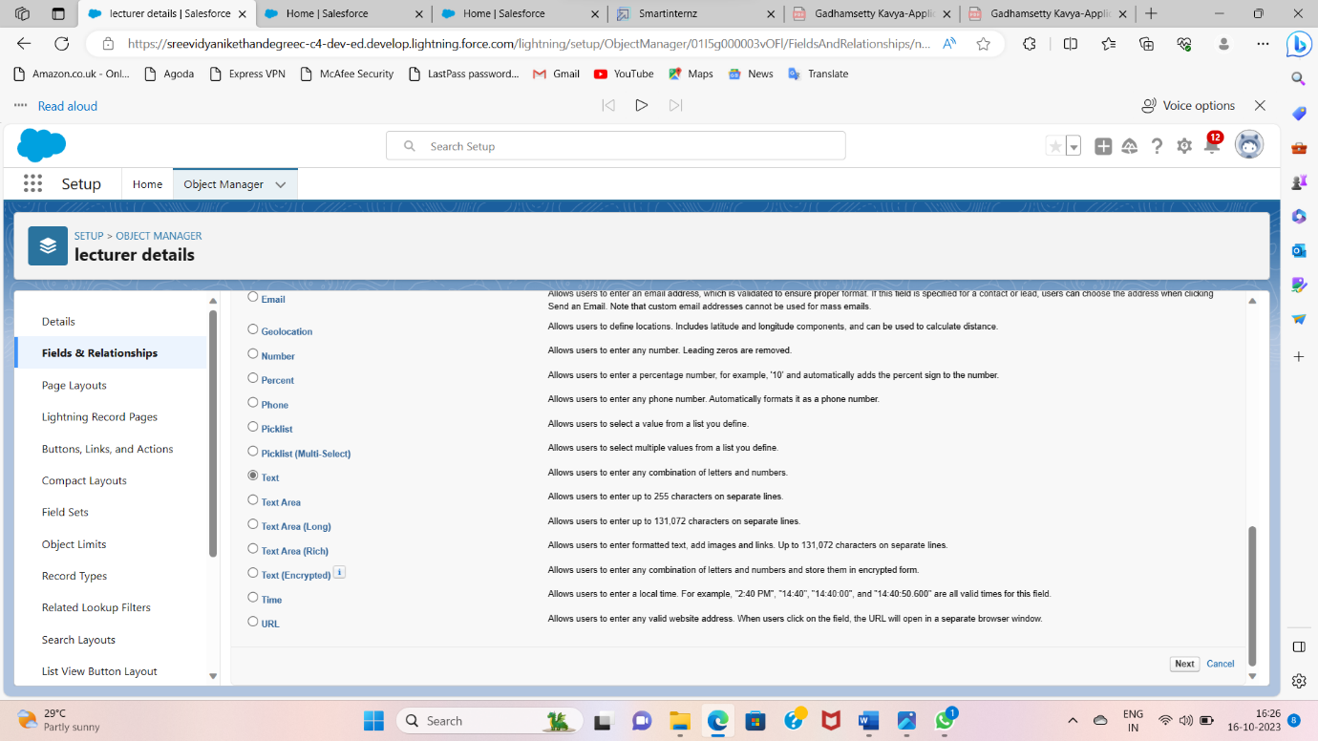

7. For Field Label, enter Lecturer Role

8. Enter Length 40

9. Click Next, Next, then Save & New.

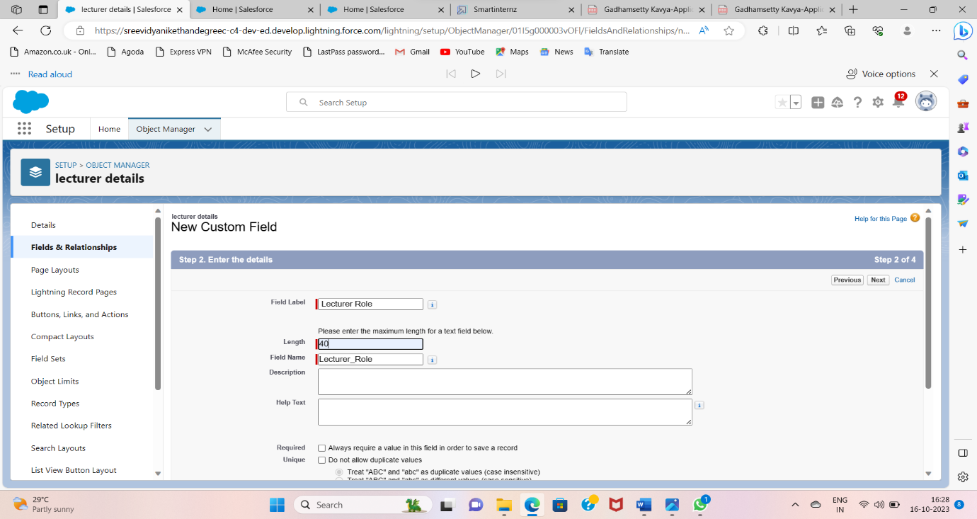

Now Let’s create a Lookup field on candidate object

1. Click the gear icon and select Setup. This launches Setup in a new tab.

2. Click the Object Manager tab next to Home.

3. Select candidate.

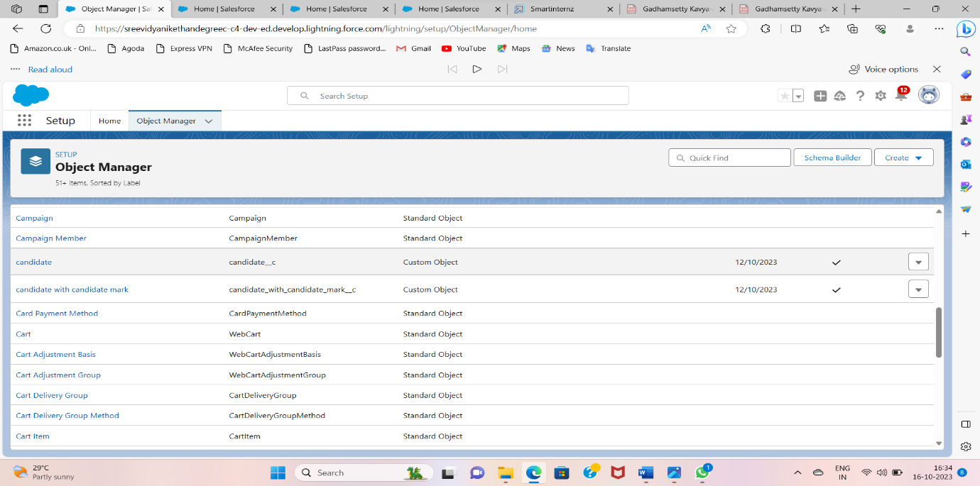

4. Select Fields & Relationships from the left navigation

5. Click New

6. Select the lookup as the Data Type, then click Next.

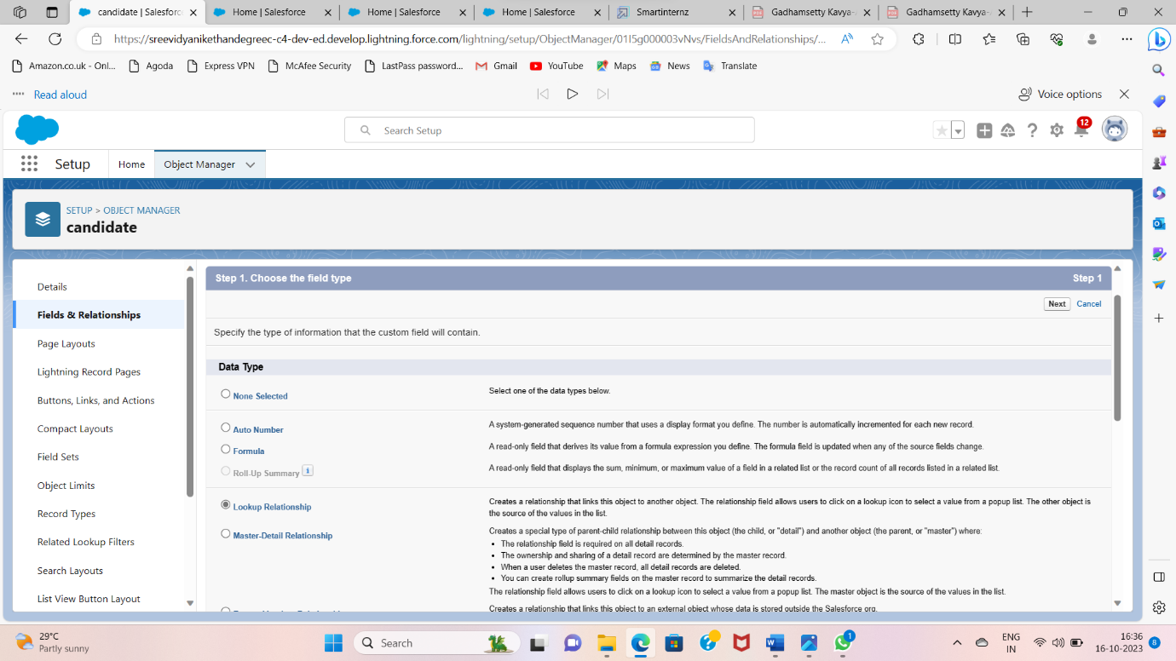

7. In related select Semester

8. For Field Label Semester Name, enter.

9. Click Next, Next, then Save & New.

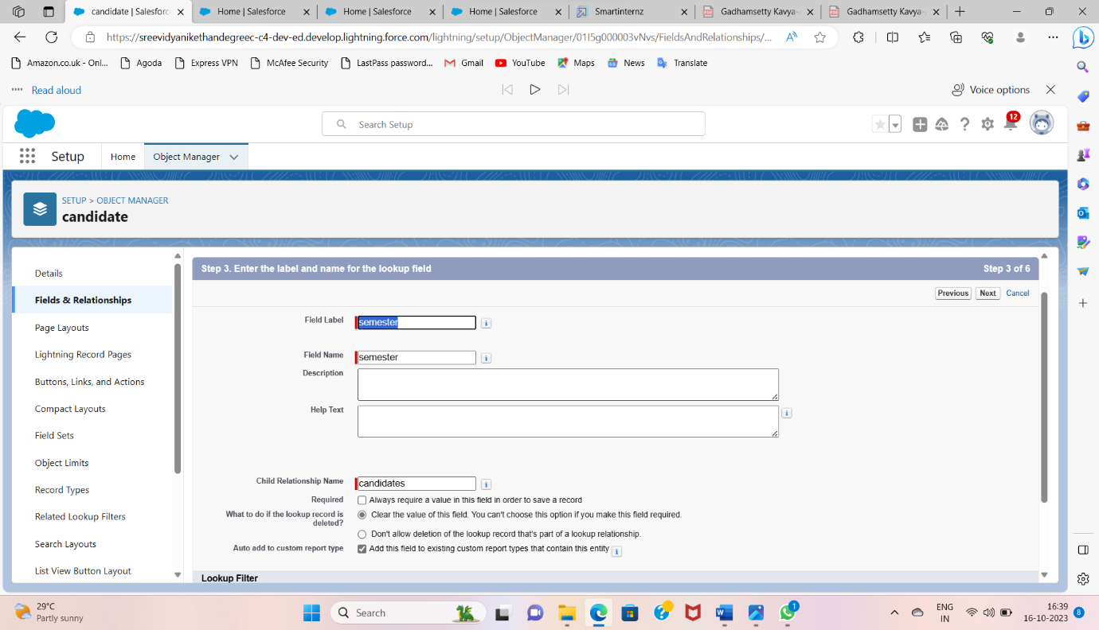

**Creation Of Auto Number Field On Candidate Object, Number Field On Course Details Object & Formula Field Course Details Object**

Let’s create a Number field on Course Details object

1. Click the gear icon and select Setup. This launches Setup in a new tab.

2. Click the Object Manager tab next to Home.

3. Select Course Detail.

4. Select Fields & Relationships from the left navigation

4. Click New & select number field, click Next

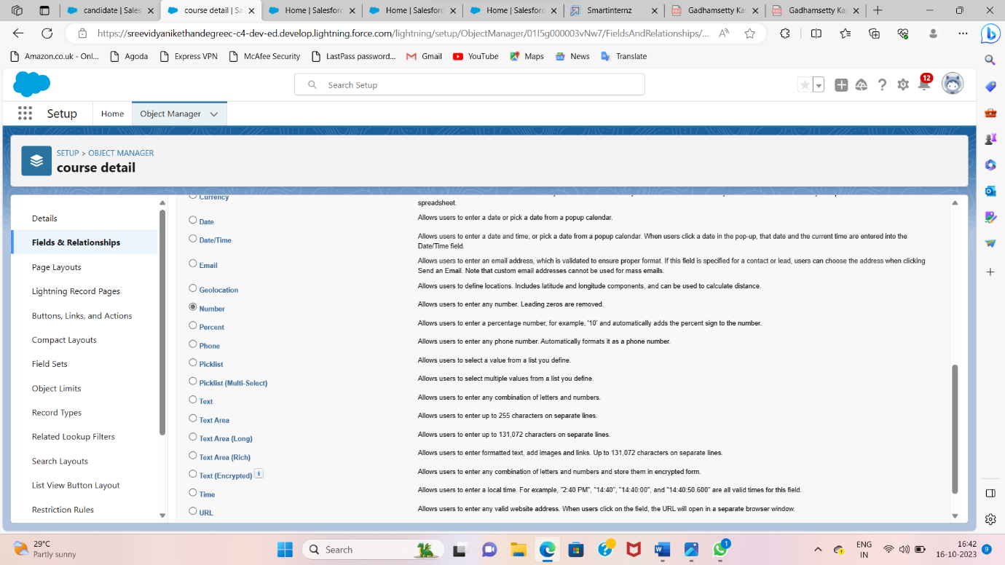

6. For Field Label Duration, enter.

7. Give Help Text- Enter Course duration value in Year

8. Click Next, Next, then Save & New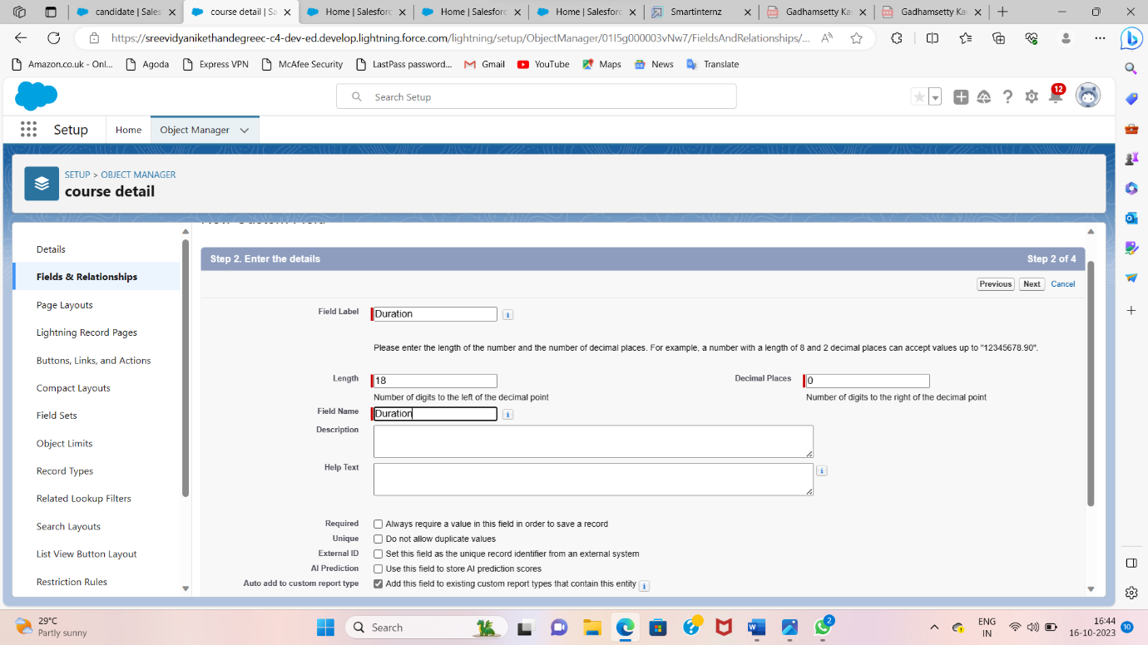.

**Creating A User**

1. From Setup, in the Quick Find box, enter Users.

2. Select Users.

3. Click New User.

4. Enter the First Name, Class, Last Name, Teacher and (Your) email address anda unique username in the form of an email address. By default, the username is the same as the email address.

5. Select a User License as salesforce.

NOTE- As Salesforce license can only be used by 2 Users at a time in Dev Org, so If you don’t find salesforce license then deactivate a user who has salesforce license Or change the license type from Salesforce to any other.

6. Select a profile as Standard user.

7. Check Generate new password and notify the user immediately to have the user’s login name and a temporary password emailed to your email.

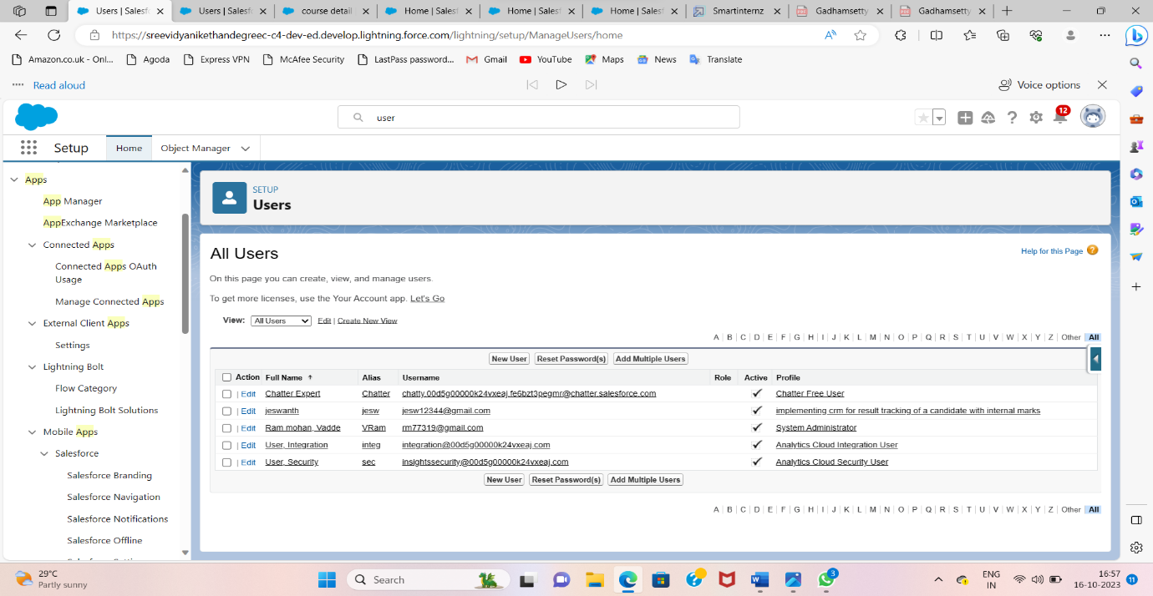

**Create Record (Course Details)**

Create Records on Course Details Objects

1. Click on App Launcher on left side of screen.

2. Search Candidate Internal Result Card App & click on it.

3. Click on Course Details tab.

4. Click new button

5. Fill all Course Details record details.

6. Click on Save Button.

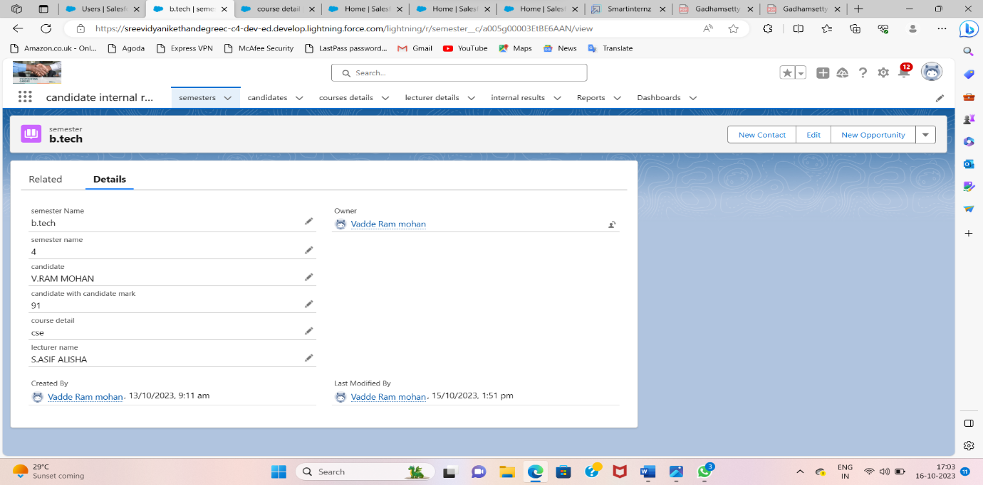

**View Report**

1. Click on App Launcher on left side of screen.

2. Search Candidate Internal Result Card App & click on it.

3. Click on Reports Tab.

4. Click on Candidate Internal Result Report and see records.

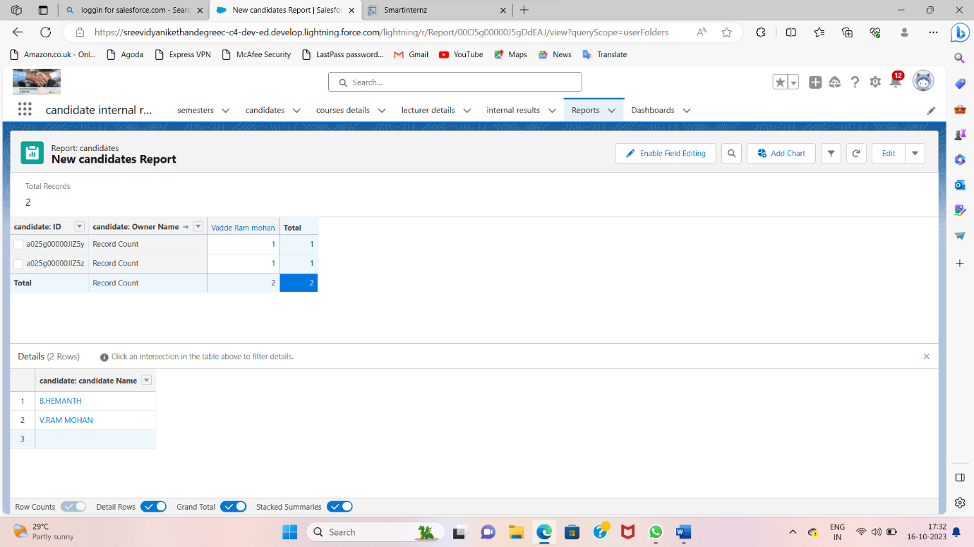

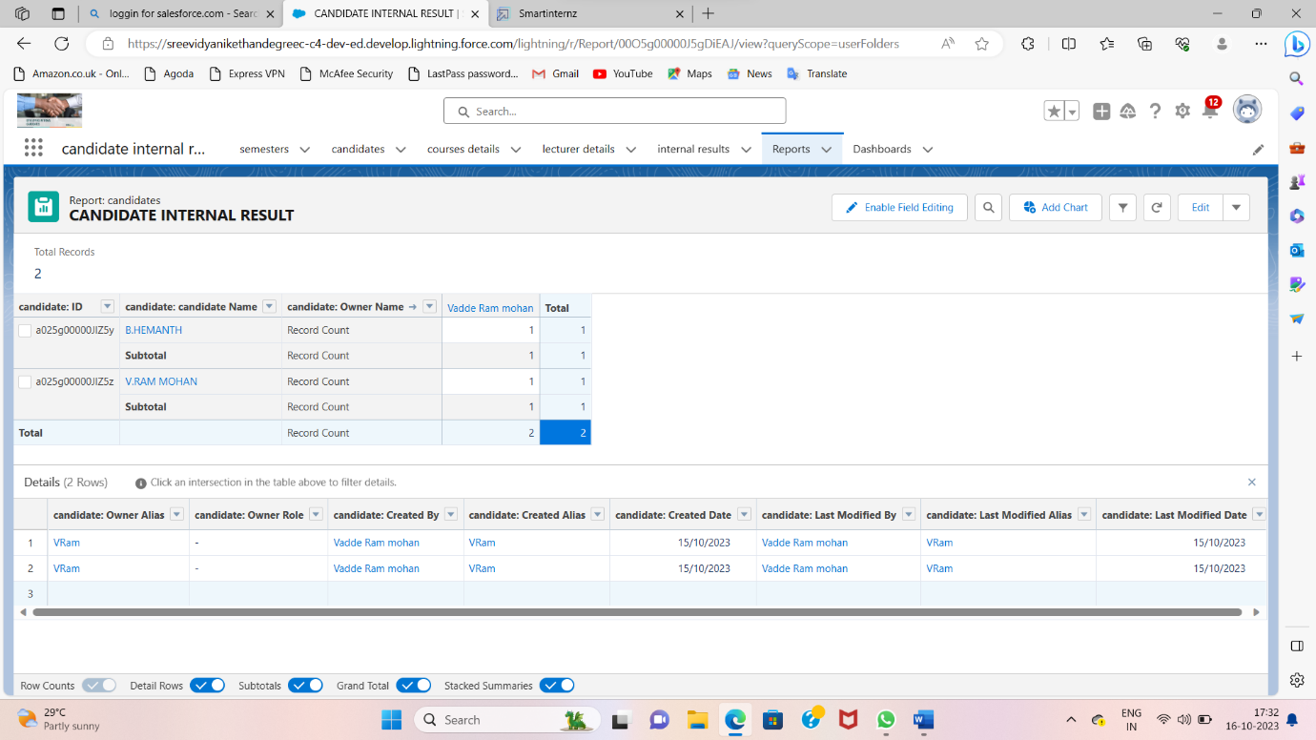

**Create Dashboard**

1. Click on Dashboards tab from the Candidate Internal Result Card application.

2. Click on new dashboard.

3. Give name- Candidate Internal Result Card

4. Click create

5.  Give your dashboard a name and click on +component

6. Select the Candidate Internal Result Report which you created.

7. For the data visualization select any of the chart, table etc. as per your choice/requirement.

8. Click add.

9. Click save.

